BLOSSOMING LOVE
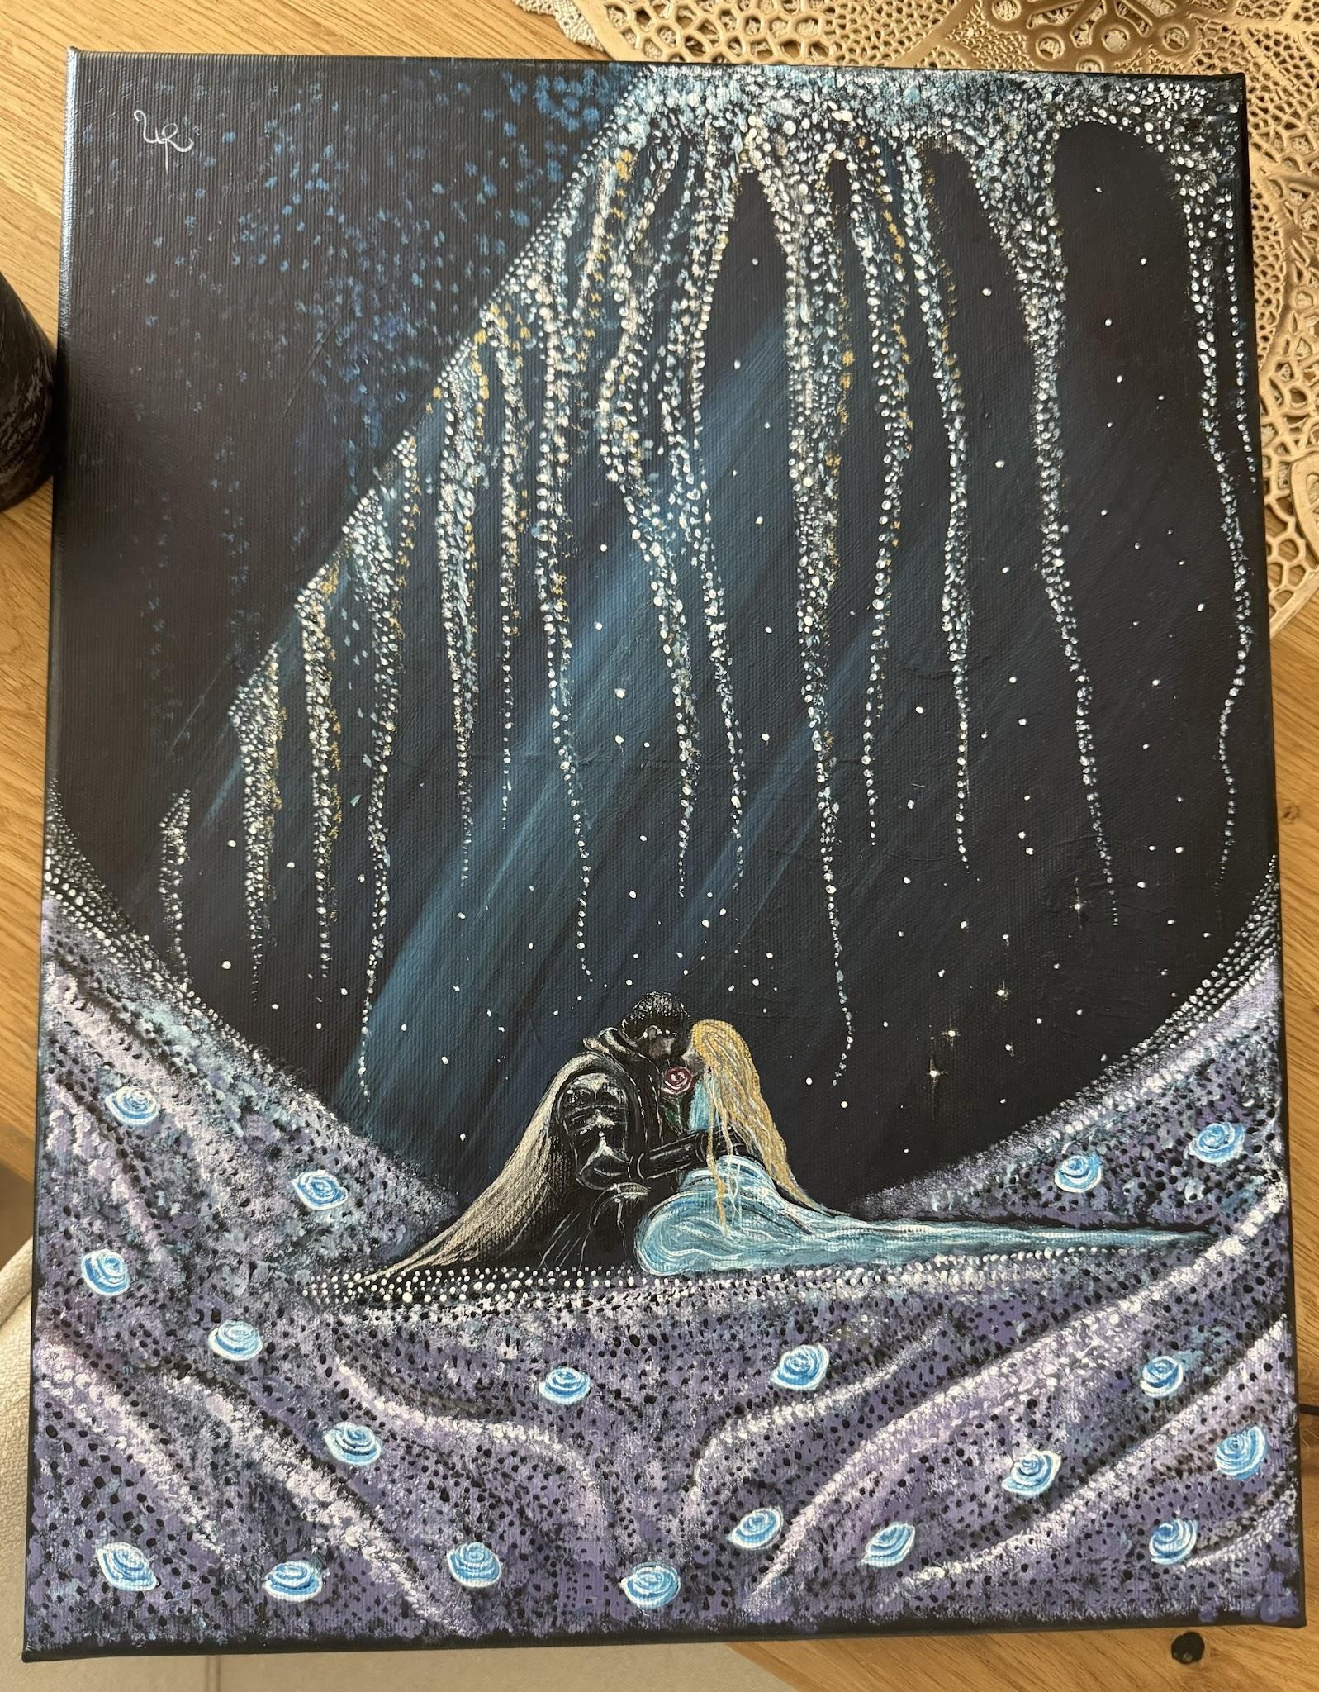

For love like ours
does not belong to one lifetime.
It blooms again and again,
like a rose returning each spring,
more beautiful than before,
its fragrance carried through eternity.

In a thousand different lifetimes,
I would choose you.

In a thousand different worlds,
I would love you.

And if forever were not enough,
I would ask eternity
for just one more lifetime—
only to find you again,
place a single red rose in your hands,
and whisper,

“My love, I have been searching for you
since the beginning of time.”

